**Git Assignment**

Objective: The goal of this assignment is to help you get familiar with basic Git commands and workflows, which are commonly used in real-world software development.

1. Create a New Repository (Creating manually and cloning it into the local machine)

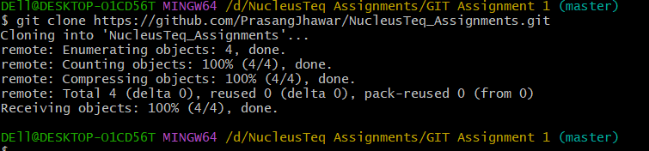

1. Create a New File

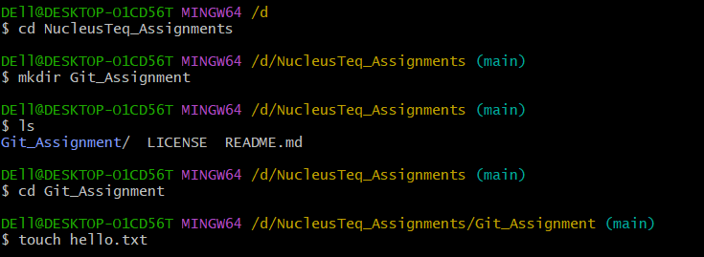

1. Create a Branch

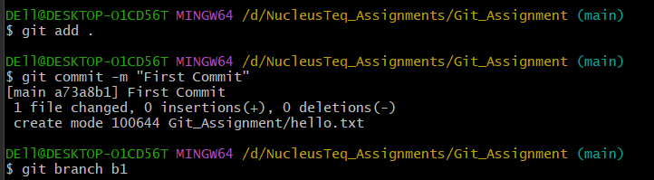

1. Make Changes in the New Branch

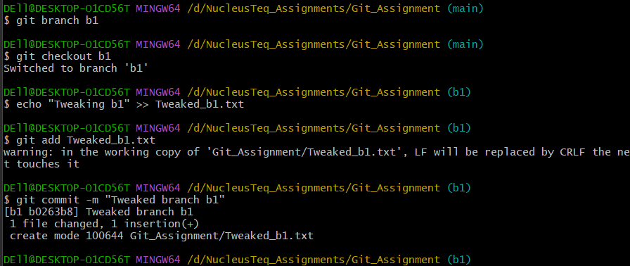

1. Create Another Branch



1. Merge Branches

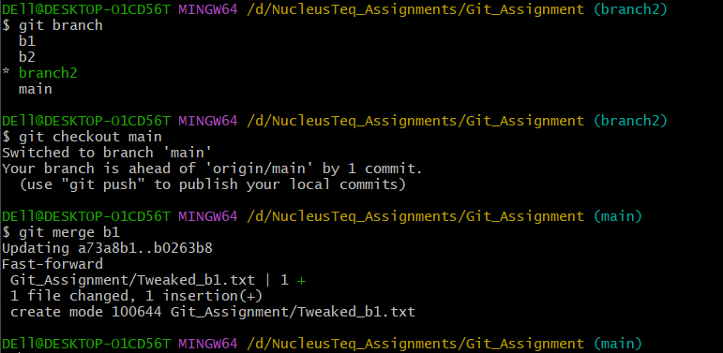

1. Pull Changes from Remote

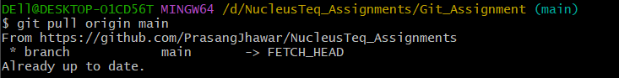

1. View Log and History

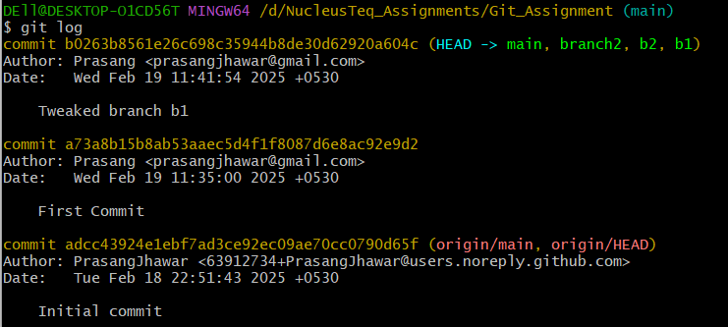

1. Git Status and Staging

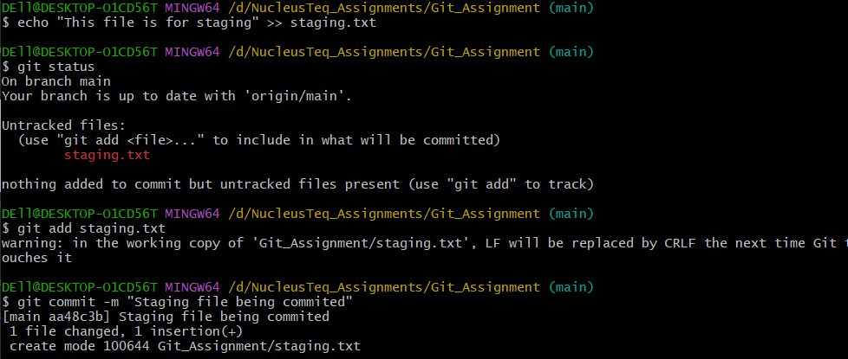

1. Revert and Reset

